241501253-YESWANTH T

Experiment 6

Workflow Automation Layer for the Vehicle Service Request Application

Aim
To design and build a complete automation layer in Zoho Creator for the Vehicle Service Request application, demonstrating all eight Workflow options: Form Workflows, Schedules, Approvals, Payments, Blueprints, Batch Workflows, Report Workflows and Functions.

Procedure
- On_ServiceRequest_Submit_Workflow (Form Workflow): fires when a record is added; emails the owner their Service Request ID and next steps, and notifies the front office.
- Daily_Service_Reminder_Schedule (Schedule): runs every evening and reminds owners with a service booking the next day, with drop-off time, bay details and a document checklist.
- Service_Estimate_Approval (Approval): only requests whose Net Service Cost Payable is above the threshold need Service Manager approval before work begins.
- Service_Fee_Payment_Workflow (Payments): generates a payment link from Net_Service_Cost_Payable, updates Payment_Status on success and flags failures for follow-up.
- Service_Lifecycle_Blueprint (Blueprint): restricts each stage transition (Requested, In Diagnosis, In Repair, Ready for Pickup, Delivered) to specific roles and gives an auditable trail.
- Bulk_ReadyForPickup_Batch (Batch Workflow): notifies owners of all Ready for Pickup vehicles in batches to avoid timeouts.
- OnEdit_Recalculate_NetCost_Workflow (Report Workflow): keeps Net_Service_Cost_Payable accurate when the discount percentage is edited in the report grid.
- Generate_ServiceInvoice_Function (Function): a reusable Deluge function called on status change to Delivered, from a resend button, or from the batch workflow.

Sample Deluge: Form Workflow (On Success)
s e n d m a i l [
f r o m : z o h o . a d m i n u s e r i d t o : i n p u t . E m a i l _ A d d r e s s
s u b j e c t : " S e r v i c e R e q u e s t R e c e i v e d - " + i n p u t . S e r v i c e _ R e q u e s t _ I D
m e s s a g e : " D e a r " + i n p u t . O w n e r _ N a m e . f i r s t _ n a m e + " , y o u r r e q u e s t f o r v e h i c l e "
+ i n p u t . V e h i c l e _ R e g i s t r a t i o n _ N u m b e r + " i s r e g i s t e r e d . "
+ " O u r t e a m w i l l s h a r e t h e e s t i m a t e b e f o r e a n y w o r k b e g i n s . "
]

Process Diagram
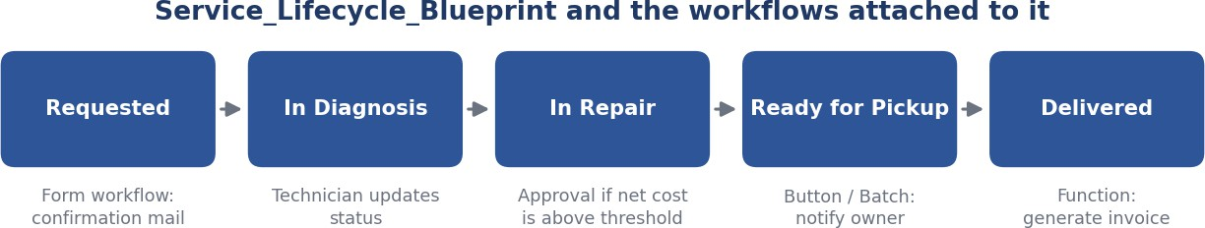
Figure 1: Diagram of Service_Lifecycle_Blueprint and the workflows attached to it (illustrative diagram, not a screenshot).

Reminder Email (Expected)
S u b j e c t : S e r v i c e R e m i n d e r - T o m o r r o w

D e a r P r i y a S h a r m a ,
Y o u r v e h i c l e T N 3 8 C D 1 2 3 4 i s b o o k e d f o r s e r v i c e t o m o r r o w . P l e a s e d r o p o f f t h e v e h i c l e a t t h e s c h e d u l e d t i m e a n d c a r r y t h e R C b o o k a n d i n s u r a n c e c o p y .

R e g a r d s ,
V e h i c l e S e r v i c e C e n t e r

Result
A complete automation layer covering all eight Workflow options was created for the Vehicle Service Request application in Zoho Creator.

